GreenGrow Agriculture Analytics

Lane Dorscher
CYBR250-T301 Intro to Cyber Threats, Tech
Bellevue University
12/07/2025
Jason Kramer

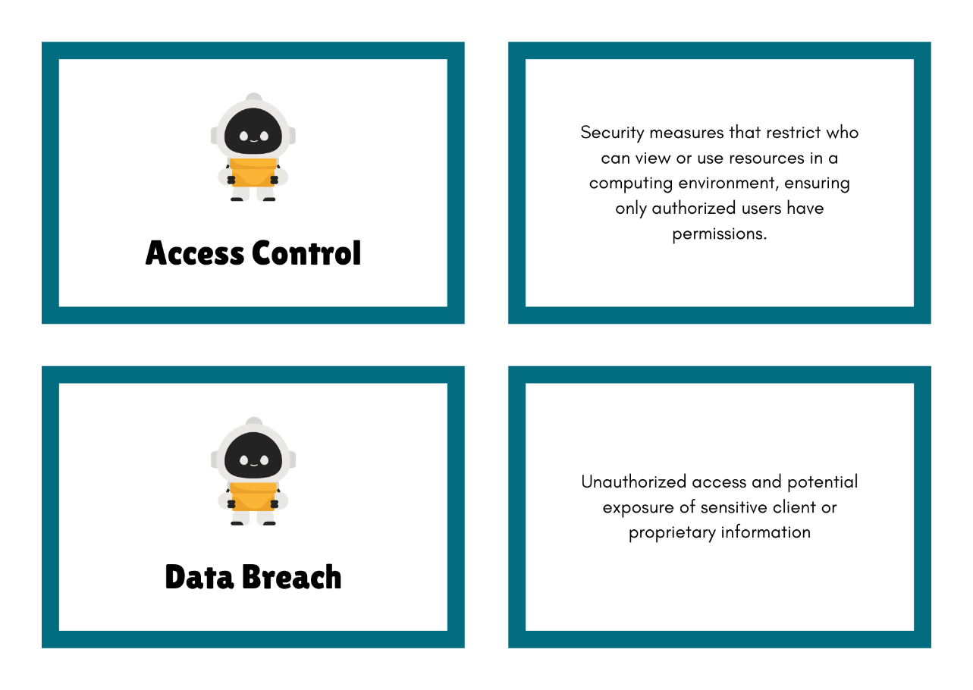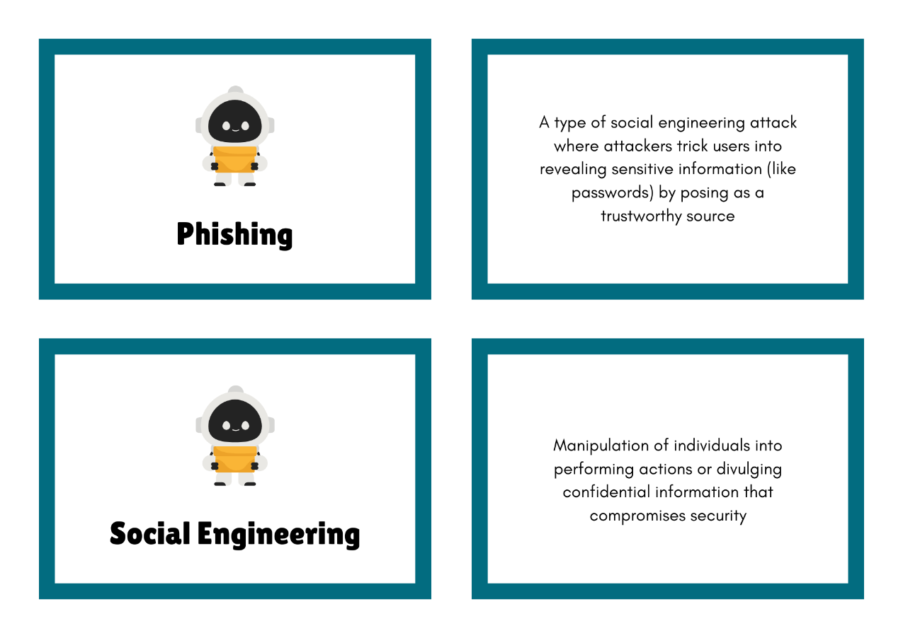
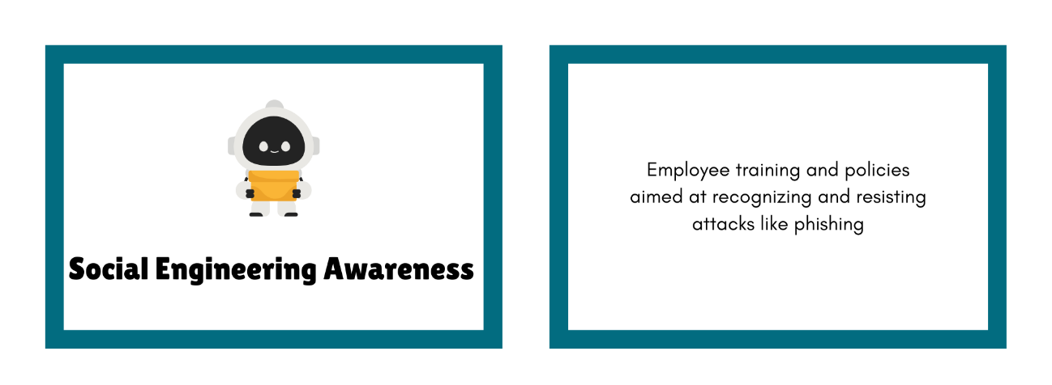

To: GreenGrow Cybersecurity Team
From: Lane Dorscher, Incident Response Analyst
Date: 12/07/2025
Subject: Updated Findings on Unauthorized Access Incident
Team,
Following continued review of raw network logs from the weekend’s phishing attack, I have identified additional indicators that may guide our investigation. Two notable examples include:
- 2023-11-13 16:47:37 — cooperated.org — PASS — BytesOut: 9,822
This transaction shows a successful outbound transfer to an unapproved external domain. The substantial data flow suggests possible exfiltration. Correlating this with affected accounts can help determine which user credentials were compromised and the scope of exposure.
- 2023-11-13 16:54:21 — twittle-twattle.com — PASS — BytesOut: 8,215
While previous attempts to this domain were blocked, this successful transaction indicates persistence by the attacker. It highlights the importance of monitoring repeated attempts and identifying suspicious domains that could act as command-and-control points.
These findings will assist in mapping the attack timeline, identifying compromised accounts, and providing actionable intelligence to law enforcement and incident response teams. Immediate follow-up includes locking affected accounts, monitoring network traffic, and updating firewall rules to block suspicious domains.

Historical Context Sidebar: The 2010 Stuxnet Worm
In 2010, the Stuxnet worm emerged as a highly sophisticated cyberattack that targeted industrial control systems, specifically Iran’s nuclear centrifuges. Unlike typical malware, Stuxnet could manipulate automated machinery, bypass conventional security defenses, and cause physical damage to operations. This attack demonstrated the vulnerability of connected industrial systems and highlighted the importance of protecting IoT and automation technologies. For GreenGrow, Stuxnet serves as a cautionary example: automated irrigation systems and connected sensors could be compromised if attackers gain access. Modern cybersecurity practices inspired by Stuxnet emphasize defense-in-depth, robust access control, continuous monitoring, and employee training against social engineering—measures critical to preventing a similar incident.

As a CISA agent responding to the cybersecurity incident at GreenGrow, my job would be to investigate the attack, reduce the damage, and help the company improve its security. When first notified, I would work with GreenGrow’s IT and incident response teams to understand the full scope of the attack. This means figuring out which employee accounts were compromised and which systems, like the automated irrigation controls or cloud platform, were affected.
To investigate properly, I would need network logs, email headers, and a list of suspicious domains. This information would help me see how the phishing emails led to unauthorized access and identify any unusual activity. By looking at the timeline of the attack and tracking where data might have gone, I could help the team understand the steps the attackers took and how to stop them.
Immediate actions would include having affected employees reset their passwords, isolating accounts that were hacked, revoking any unauthorized access, and blocking harmful domains in the firewall and DNS settings. I would also recommend checking the network for unusual traffic and making sure IoT devices like sensors and irrigation systems are secure.
Since I am new to cybersecurity, I would focus on learning from this incident while helping staff understand phishing and password safety. I would also document everything carefully and share findings with other federal agencies and industry partners. This approach helps prevent future attacks and keeps GreenGrow’s systems and client data safer.

References:
Encyclopaedia Britannica. (n.d.). Stuxnet. Britannica. Retrieved from https://www.britannica.com/technology/Stuxnet
CISA / Government Response
Cybersecurity and Infrastructure Security Agency. (n.d.). Incident detection, response, and prevention. CISA. Retrieved from https://www.cisa.gov/topics/cyber-threats-and-advisories/incident-detection-response-and-prevention
Cybersecurity and Infrastructure Security Agency. (n.d.). Situational awareness and incident response. CISA. Retrieved from https://www.cisa.gov/situational-awareness-and-incident-response

